Geometry: Unit 6, Lesson 7
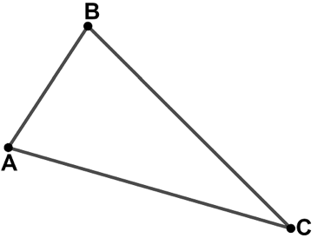
- Triangle $ABC$ is shown. What is the included angle for sides $AB$ and $BC$?

$$∠ABC$$

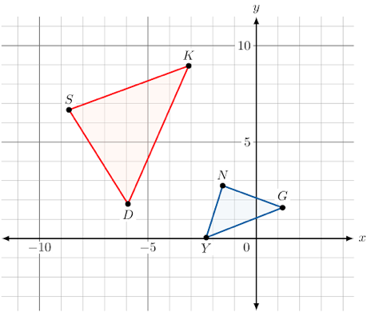
- Triangle $SKD$ and $YNG$ are shown. $∆SKD\sim ∆NGY$. What corresponds to $∠Y$?

$$∠D$$

- What is true about all corresponding angles of similar figures?

All corresponding angles are congruent

